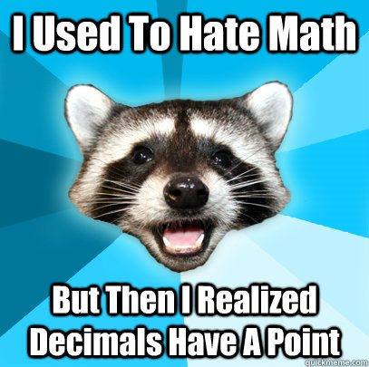
NAME______________
Revision
Operations with Decimals

PART A: NON-CALCULATOR
When completing the following section, you are not allowed to use a calculator.

- Complete the following table

Question | Number | 10% | 20%
1 | 450
2 | 1200
3 | 87

- Convert the following

Question | Fraction | Decimal | Percentage
1 |  |  | 25%
2 |  | 0.7
3 | $$\frac{4}{10}$$
4 |  |  | 100%
5 |  | 0.25
6 | $$\frac{7}{25}$$
7 | $$\frac{3}{4}$$
8 |  |  | 50%

- In the box below calculate $921.74+2.7$

- In the box below calculate $64.32+21.63$

- In the box below calculate $94.9-41.871$

- In the box below calculate $686.4-199.61$

- In the box below calculate $9.62 × 0.48$

- In the box below calculate $5.78 × 2.4$

- In the box below calculate $4.31 × 0.16$

- In the box below calculate $4.04 × 3.12$

- In the box below calculate $8982 ÷ 100$

- In the box below calculate $4381.4÷ 100$

- In the box below calculate $94.8 ÷ 10$

- In the box below calculate $137.6 ÷10$

- Explain how you convert decimals to fractions

_______________________________________________________________________________________________________________________________________________________________________________________________________________

- Convert the following decimals to fractions.

Decimal | Fraction |  | Decimal | Fraction
0.467 |  |  | 0.22
0.3 |  |  | 0.9
0.95 |  |  | 0.17
0.1 |  |  | 0.782

- Jerry, an electrician, worked 7 months out of the year.

- What fraction of the year did Jerry work?

- What percent of the year did he work?

- A sunflower grows to be 400cm tall. After four weeks, it was 50% of this height. How tall was the sunflower after four weeks?

- In a packet of skittles, 25% are red. What percentage are not red?

- Frazer scores 75% in a spelling test. What percentage did he get wrong?

- Children had to pick their favourite sport from basketball, football and hockey. 35% chose basketball and 28% chose hockey. What percentage chose football?

- 38% of the animals in a dog and cat rescue centre are cats. What percentage are dogs?

- In a survey 6% of adults did not know how to ride a bike. What percentage could ride?

- In a group of children, 78% can swim. What percentage are non-swimmers?

